RMP WHITE
SECTION 1: Identification of the substance/mixture and of the company/undertaking

1.1 | Product identifier
 | Product name: | RMP WHITE
 | Product code: | 4980-6-3
 | Product description: | White road marking paint.
 | CAS No.: | Not applicable.
 | EC No.: | Not applicable.
 | Index No.: | Not applicable.

1.2 | Relevant identified uses of the substance or mixture and uses advised against
 | Identified use(s): | Quick drying paint for line marking on concrete and tarmac.
 | Uses advised against: | Follow supplier’s recommendations on correct use of the product.

1.3 | Details of the supplier of the safety data sheet
 | Manufacturer/Supplier: | S G Bailey Paints Limited  Unit 15A  Griffin Mill  London Road  Thrupp  Stroud  Gloucestershire  GL5 2AZ
 | Telephone: | +44 (0)1453 882237
 | E-mail: | richard@baileypaints.co.uk

1.4 | Emergency telephone number
 | In case of emergency, call: | +44 (0) 7774 460658 (UK number, 24 hours, 7 days)

SECTION 2: Hazard Identification

2.1 Classification of the substance or mixture

Classification according to Regulation (EC) No. 1272/2008 (CLP)
Flammable Liquid 3; H226
Acute Toxicity 4; H312
Acute Toxicity 4; H332
Skin Irritant 2; H315
Eye Irritant 2; H319
Specific Target Organ Toxicity Single Exposure 3; H335
Specific Target Organ Toxicity Repeated Exposure 2; H373
Aspiration Toxicity 1, H304

2.2 Label elements according to Regulation (EC) No. 1272/2008 (CLP)

 | Hazard pictogram(s):
 | 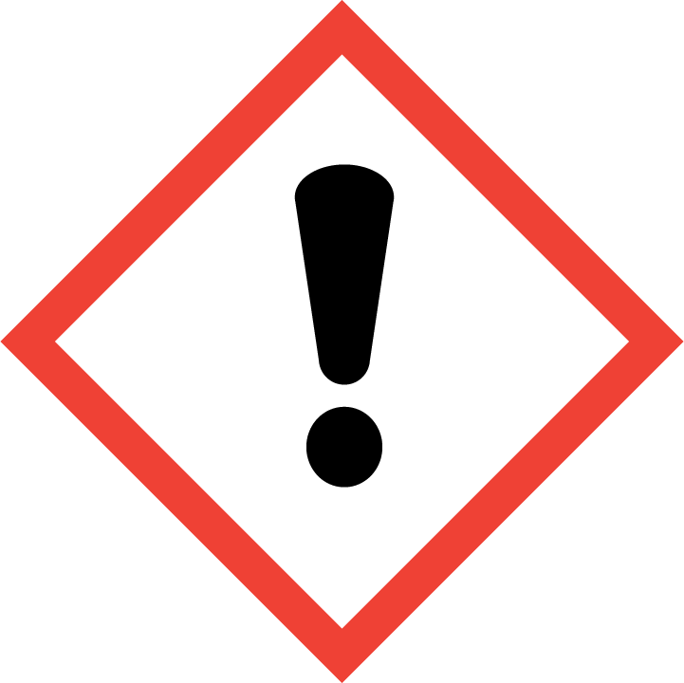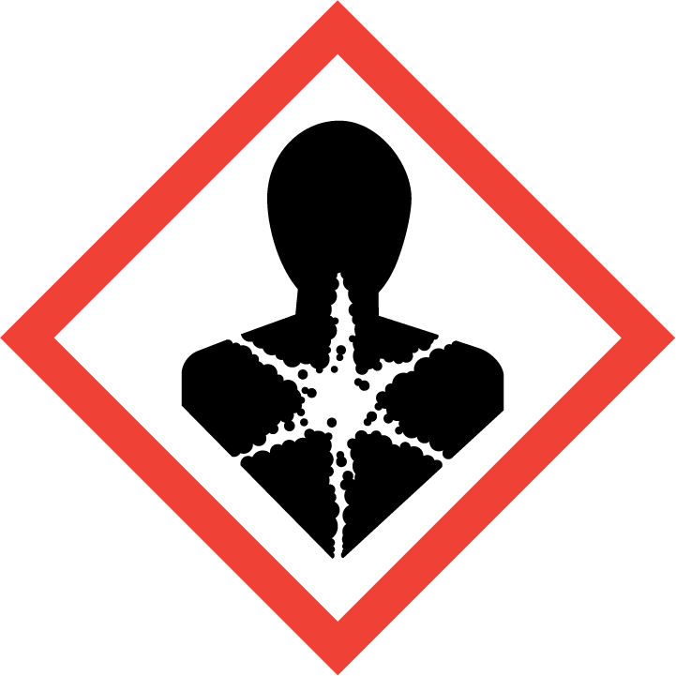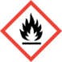
 | Signal Word: | Danger
 | Hazard Statement(s): | H226: Flammable liquid and vapour.  H312: Harmful in contact with skin.  H332: Harmful if inhaled.  H315: Causes skin irritation.  H319: Causes serious eye irritation.  H335: May cause respiratory irritation.  H373: May cause damage to organs through prolonged or repeated exposure if inhaled.  H304: May be fatal if swallowed and enters airways.
 | Precautionary Statement(s): | P210: Keep away from heat / sparks / open flames / hot surfaces. No smoking.  P241: Use explosion-proof electrical equipment.  P260: Do not breathe vapours.  P303 + P361 + P353: IF ON SKIN (or hair): Remove/take off immediately all contaminated clothing. Rinse skin with water/shower.  P304 + P340: IF INHALED: Remove victim to fresh air and keep at rest in a position comfortable for breathing.  P301 + P310: IF SWALLOWED: Immediately call a doctor/physician.  P331: Do NOT induce vomiting.  P403 + P235: Store in a well-ventilated place. Keep cool.  P501: Dispose of contents/container to hazardous waste.
 | Supplemental Hazard information (EU): | None
 | Contains: | Xylene, Ethylbenzene

2.3 | Other hazards:
 | Product may charge electrostatically.
SECTION 3: Composition

3.2 Mixtures

Classification according to Regulation (EC) No. 1272/2008 (CLP)
Chemical name | % w/w | CAS No. | EC No. | Index No. | Classification
Xylene  REACH Registration no.:  01-2119488216-32 | 15 - 26 | 1330-20-7 | 215-535-7 | 601-022-00-9 | Flam. Liq. 3; H226  Acute Tox. 4; H312  Acute Tox. 4; H332  Skin Irrit. 2; H315  Eye Irrit. 2; H319  STOT SE3; H335  STOT RE2; H373  Asp. Tox. 1; H304
Ethylbenzene | 4 | 100-41-4 | 202-849-4 | 601-023-00-4 | Flam. Liq. 2; H225  Acute Tox. 4; H332

See Section 16 for full description of H statements.

SECTION 4: First Aid Measures

4.1 Description of first aid measures

 | INHALATION: | Remove patient to fresh air and keep at rest. If there are breathing problems, seek medical advice.
 | SKIN CONTACT: | Remove contaminated clothing immediately. Rinse skin with water or shower and wash with soap and water. Seek medical advice if symptoms persist.
 | EYE CONTACT: | Rinse cautiously with water for several minutes. Remove contact lenses if present and easy to do. Continue rinsing. Seek medical advice if irritation persists.
 | INGESTION: | Give small quantities of water to drink. Do NOT induce vomiting. Obtain immediate medical attention.

4.2 Most important symptoms and effects, both acute and delayed

Serious eye irritation, skin irritation, respiratory irritation.

4.3 Indication of any immediate medical attention and special treatments needed

If ingested, product may be aspirated into the lungs and cause chemical pneumonitis. Treat symptomatically.

SECTION 5: Fire-fighting Measures

5.1 Extinguishing Media
 | Suitable extinguishing media: | Foam, CO₂ or dry powder.
 | Unsuitable extinguishing media: | Do not use water jet.

5.2 Special hazards arising from the substance or mixture
Vapours may be heavier than air and may travel along the ground to a distant ignition source and flash back, causing fire or explosion. Containers may rupture on heating. Toxic gases may be formed in a fire.

5.3 Advice for fire-fighters
FLAMMABLE. Evacuate area. Prevent run-off from fire control or dilution from entering drains or water courses. Self-contained breathing apparatus and suitable protective clothing should be worn in fire conditions. Keep fire-exposed containers cool by spraying with water. Do not allow to enter drains, sewers or watercourses.

Flash point: 24 - 32°C.

SECTION 6: Accidental Release Measures

6.1 Personal precautions, protective equipment and emergency procedures

6.1.1 For non-emergency personnel
Eliminate sources of ignition. Ensure adequate ventilation. Avoid contact with skin and eyes. Avoid inhalation of vapours. Wear suitable personal protective equipment. Wear appropriate respirator when ventilation is inadequate (see Section 8).

6.1.2 For emergency responders
Keep unnecessary personnel away. Wear suitable protective clothing (see Section 8). Contaminated clothing should be thoroughly cleaned.

6.2 Environmental precautions
Collect spillage. Do not allow to enter drains, sewers or watercourses. Spillages or uncontrolled discharges into watercourses must be alerted to the Environment Agency or other appropriate regulatory body.

6.3 Methods and materials for containment and clearing up
6.3.1 For containment
Stop the leak if it is safe to do so. Contain the spillage with sand, earth or any suitable adsorbent material.

6.3.2 For cleaning up
Use sand, earth or any suitable non-combustible adsorbent material to adsorb spillages. Using non-sparking tools transfer the contaminated absorbent material into sealable containers for disposal. Containers should be sealed before being disposed of via an authorised waste disposal contractor.

6.3.3 Other advice
None

6.4 Reference to other sections
See Section 8 for personal protective equipment. See Section 13 for waste disposal.

SECTION 7: Handling and Storage

7.1 Precautions for safe handling
Provide adequate ventilation, including local extraction to ensure the occupational exposure limit is not exceeded. Do not inhale vapours. Avoid contact with skin and eyes. Wear suitable personal protective equipment (see Section 8). Eliminate all sources of ignition. Electrical equipment should be protected to the appropriate standard.

Do not eat, drink or smoke when using this product. Wash exposed skin after use. Contaminated work clothing should not be allowed out of the workplace. Contaminated clothing should be thoroughly cleaned or disposed of as hazardous waste.

7.2 Conditions for safe storage, including any incompatibilities
Keep away from heat and sources of ignition. Keep from direct sunlight. Store locked up. Store only in the original container. Do not pressurise container. Product may charge electrostatically so all containers and associated equipment should be earthed and bonded to prevent static charge accumulation. Store in a cool, well ventilated place. Empty containers retain product residue and can be hazardous.

Ensure compliance with all regulations and guidance associated with the storage and use of flammable liquids.

See section 10 for incompatible materials.

7.3 Specific end uses(s)
Quick drying paint for line marking on concrete and tarmac.

SECTION 8: Exposure Controls/Personal Protection

8.1 Control parameters

Workplace exposure limits (WEL) – United Kingdom
Source: EH40/2005, 2nd Ed., 2011
Substance | CAS no. | LTEL (8 hr TWA) |  | STEL (15 min)
Substance | CAS no. | ppm | mg/m³ | ppm | mg/m³
Xylene | 1330-20-7 | 50 | 220 | 100 | 441
Ethylbenzene | 100-41-4 | 100 | 441 | 125 | 552

Other exposure limits

Consult applicable national legislation for WELs in other countries.

Biological limits

Substance | Specimen | Sampling time | Limit | Determinant | Source
Xylene | Creatinine in urine | End of shift | 650 mmol/mol | Methyl hippuric acid | UK BMGV

Derived No-Effect Level (DNEL) - industry

Substance | Dermal | Inhalation | Oral
Xylene | Long-term: 3182 mg/kg/day | Short-term: 442 mg/m³  Long-term: 180 mg/kg/day | Not available

Predicted No-Effect Concentration (PNEC)
Substance | Aqua (fresh water) | Aqua (marine water) | Aqua (intermittent releases) | Sewage Treatment Plants | Sediment | Soil | Oral (secondary poisoning)
Xylene | 0.327 mg/l | 0.327 mg/l | 0.327 mg/l | 6.58 mg/l | 12.46 mg/kg (dry weight) | 2.31 mg/kg | NA

8.2 Exposure controls

8.2.1 Appropriate engineering controls
Provide adequate ventilation, including appropriate local extraction. Electrical equipment should be protected to the appropriate standard.

8.2.2 | Personal protection: | A suitable and sufficient COSHH assessment must be undertaken and appropriate and compliant personal protective equipment (PPE) provided and used.
 | Eye protection: | Goggles or glasses giving complete protection to eyes (EN 166) or face shield.
 | Skin protection: | Appropriate barrier creams.
 | Hand protection: | Chemical resistant gloves. (EN 374).
 | Other: | Long sleeve protective clothing. Plastic apron. Rubber boots.
 | Respiratory protection: | In the case of insufficient ventilation, wear suitable respiratory equipment.
8.2.3 Environmental exposure controls
Inform environmental manager of all incidents involving this product.

SECTION 9: Physical and Chemical Properties

9.1 Information on basic physical and chemical properties

Appearance: | White viscous liquid
Odour: | Solvent
Odour threshold: | Not available
pH: | Not applicable
Melting/freezing point: | Not available
Initial boiling point and boiling range: | Not available
Flash point: | 24 - 32°C
Evaporation rate: | Not available
Flammability (solid; gas): | Not applicable
Upper/lower flammability or explosive limits: | Not available
Vapour pressure: | Not available.
Vapour density: | Not available
Relative density: | 1.4 to 1.6 (Water = 1)
Solubility: | Insoluble in water
Partition coefficient: n-octanol/water: | Not available
Auto-ignition temperature: | Not available
Decomposition temperature: | Not available
Viscosity: | Not available
Explosive properties: | Vapour may form explosive mixture with air
Oxidising properties: | Not oxidising
9.2 Other information
None

SECTION 10: Stability and Reactivity

10.1 | Reactivity | Reacts with strong oxidising agents.
10.2 | Chemical stability | Stable under normal conditions.
10.3 | Possibility of hazardous reactions | No hazardous reactions expected during normal use.
10.4 | Conditions to avoid | Keep away from sources of ignition, hot surfaces, direct sunlight and other sources of ignition.
10.5 | Incompatible materials | Strong oxidising agents.
10.6 | Hazardous decomposition products | Combustion may liberate toxic smoke, fumes, incomplete combustion products and oxides of carbon.

SECTION 11: Toxicological Information

11.1 | Information on toxicological effects
 | Acute toxicity | Harmful in contact with skin.  Harmful if inhaled.
 | Skin corrosion/irritation | Irritating to skin.
 | Serious eye damage/irritation | Causes serious eye irritation.
 | Skin sensitisation | Not classified. The product does not contain substances classified as skin sensitisers above the classification thresholds.
 | Respiratory irritation | Vapour irritates the nose, throat and lungs.
 | Respiratory sensitisation | No evidence of respiratory sensitisation.
 | Germ cell mutagenicity | Not mutagenic.
 | Carcinogenicity | Not classified. The product does not contain substances classified as carcinogenic above the classification thresholds.
 | Reproductive toxicity | Not classified. The product does not contain substances classified for reproductive toxicity above the classification thresholds.
 | Specific Target Organ Toxicity – single exposure | Inhalation of high concentrations of vapour may cause respiratory tract irritation.
 | Specific Target Organ Toxicity –  repeated exposure | Prolonged or repeated inhalation of high concentrations of vapour can cause kidney, liver and central nervous system damage.
 | Aspiration hazard | If ingested, may be aspirated into the lungs and cause chemical pneumonitis
Information on likely routes of exposure

 | Inhalation | See above
 | Skin contact | See above
 | Eye contact | See above
 | Ingestion | See above
Symptoms related to the physical, chemical and toxicological characteristics |  | See above
Other information |  | None

SECTION 12: Ecological Information

12.1 | Toxicity | The product is low hazard for the environment.  The following data is for Xylene:  LC50 96h fish: 4.2. mg/l (Onchorhynchus mykiss)  EC50 48h aquatic invertebrates: 2.9 mg/l (Daphnia magna)  EC50 72h aquatic plants: 4.4.mg/l (Pseudokirkneriella subcapitata)  NOEC 96h fish early life stage: 3.3 mg/l (Menidia menidia)  NOEC 48h aquatic invertebrates: 6.8 mg/l (Daphnia magna)
12.2 | Persistence and degradability | Data for Xylene:  Readily biodegradable. Air photolysis: half-life 1.09 days. Transformation due to photolysis or hydrolysis not expected to be significant. Water degradation: 70% in 28 days; readily biodegradable in water.
12.3 | Bioaccumulative potential | Potential for Xylene to bioaccumulate is low. Log Kow (octanol/water): 3.12 (calculated).
12.4 | Mobility in soil | The product contains volatile organic compounds (VOC) which will evaporate easily from all surfaces.
12.5 | Results of PBT and vPvB assessment | Not classified as PBT/vPvB by current EU criteria.
12.6 | Other adverse effects | No other adverse effects are expected.

SECTION 13: Disposal Considerations

  - Waste treatment methods
Product and packaging to be disposed of as hazardous waste. Disposal should be in accordance with local, state or national legislation.

Contaminated adsorbent must be removed in sealed, drums and disposed of via an authorised waste disposal contractor. Do not empty into drains; dispose of this material and its container in a safe way.

Empty containers may contain residue and may be dangerous. Do not attempt to refill or clean containers without proper instructions. Do not pressurise, cut, weld, braze, solder, drill, grind or expose such containers to heat, flame, sparks, static electricity or other sources of ignition. Residual flammable vapour may cause an explosion.

SECTION 14: Transport Information

ROAD (ADR)
14.1 | UN Number | 1263
14.2 | UN Proper shipping name | PAINT
14.3 | Transport hazard class(es) | 3
14.4 | Packing group | III
14.5 | Environmental hazards | No
INLAND WATERWAYS (ADN/ADNR)
14.1 | UN Number | 1263
14.2 | UN Proper shipping name | PAINT
14.3 | Transport hazard class(es) | 3
14.4 | Packing group | III
14.5 | Environmental hazards | No
RAIL (RID)
14.1 | UN Number | 1263
14.2 | UN Proper shipping name | PAINT
14.3 | Transport hazard class(es) | 3
14.4 | Packing group | III
14.5 | Environmental hazards | No
AIR (IATA/ICAO)
14.1 | UN Number | 1263
14.2 | UN Proper shipping name | PAINT
14.3 | Transport hazard class(es) | 3
14.4 | Packing group | III
14.5 | Environmental hazards | No
SEA (IMDG)
14.1 | UN Number | 1263
14.2 | UN Proper shipping name | PAINT
14.3 | Transport hazard class(es) | 3
14.4 | Packing group | III
14.5 | Environmental hazards | No
14.6 | Transport in bulk according to Annex II of MARPOL 73/78 and the IBC code | Not intended to be transported in bulk
SECTION 15: Regulatory Information

15.1 | Safety, health and environmental regulations/legislation specific for the substance or mixture | This Safety Data Sheet was prepared in accordance with EC Regulation (EC) No. 1907/2006 as amended. The product has been classified in accordance with Regulation (EC) No. 1272/2008 (CLP).
15.2 | Chemical Safety Assessment | Not applicable.

SECTION 16: Other Information

Full text of relevant H-statements: | H225: Highly flammable liquid and vapour.  H226: Flammable liquid and vapour.  H304: May be fatal if swallowed and enters airways.  H312: Harmful in contact with skin.  H315: Causes skin irritation.  H319: Causes serious eye irritation.  H332: Harmful if inhaled.  H335: May cause respiratory irritation.  H373: May cause damage to organs through prolonged or repeated exposure.
References:
Suppliers’ Safety Data Sheets for components
Regulation (EC) No. 1272/2008
EH40/2005, 2nd Ed., 2011

Disclaimer:

THE INFORMATION PRESENTED HEREIN IS BELIEVED TO BE ACCURATE, BUT IS NOT WARRANTED TO BE, WHETHER ORIGINATING WITH THE COMPANY OR NOT. RECIPIENTS ARE ADVISED TO CONFIRM, IN ADVANCE OF NEED, THAT THE INFORMATION IS CURRENT, APPLICABLE, AND SUITABLE TO THEIR CIRCUMSTANCES.

Version history:

Version: | 1.0
Issue date: | 31/12/2016
Previous Version: | Not numbered
Issue date of previous version: | April 2004
Sections changed from previous version: | All sections reviewed and revised

